CS 255 System Design Document Template

Neo Huynh

UML Diagrams

UML Use Case Diagram
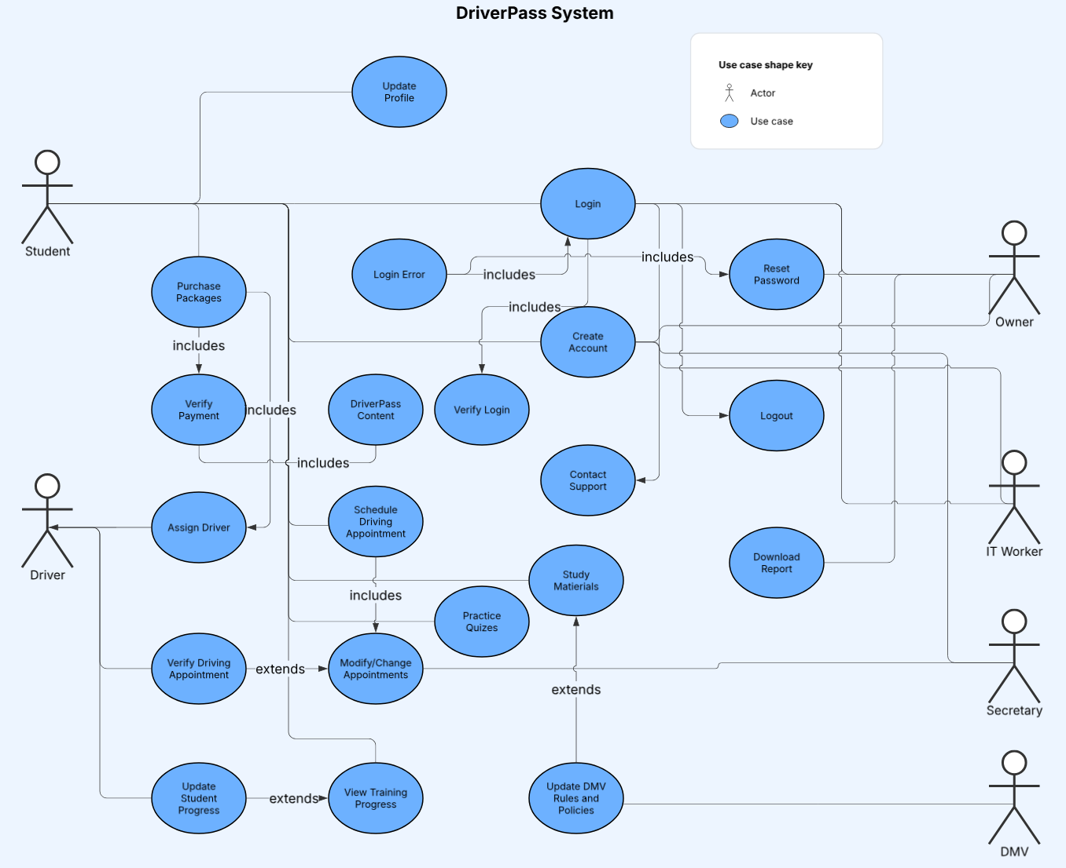

UML Activity Diagrams
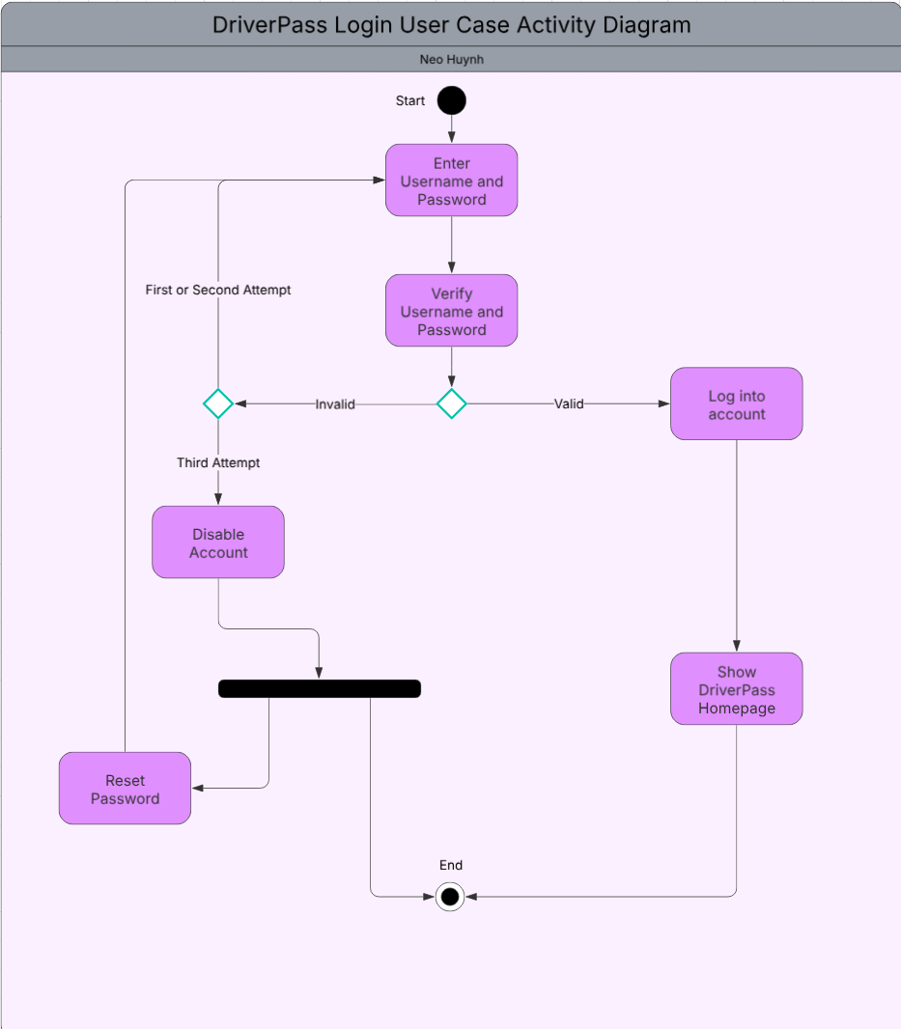
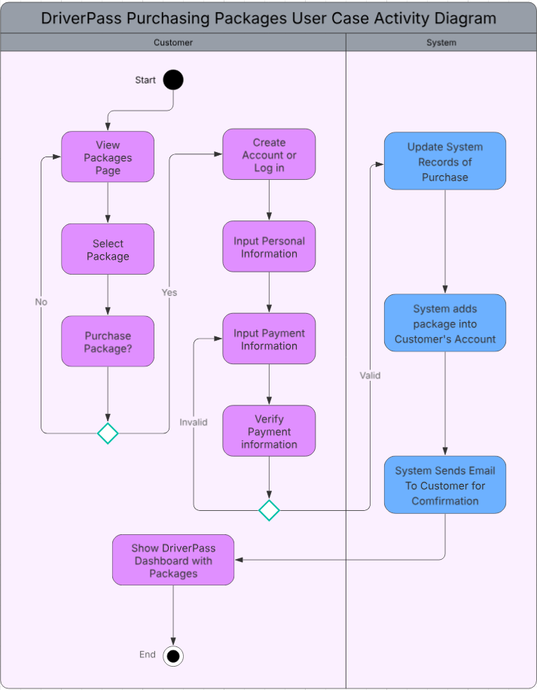

UML Sequence Diagram
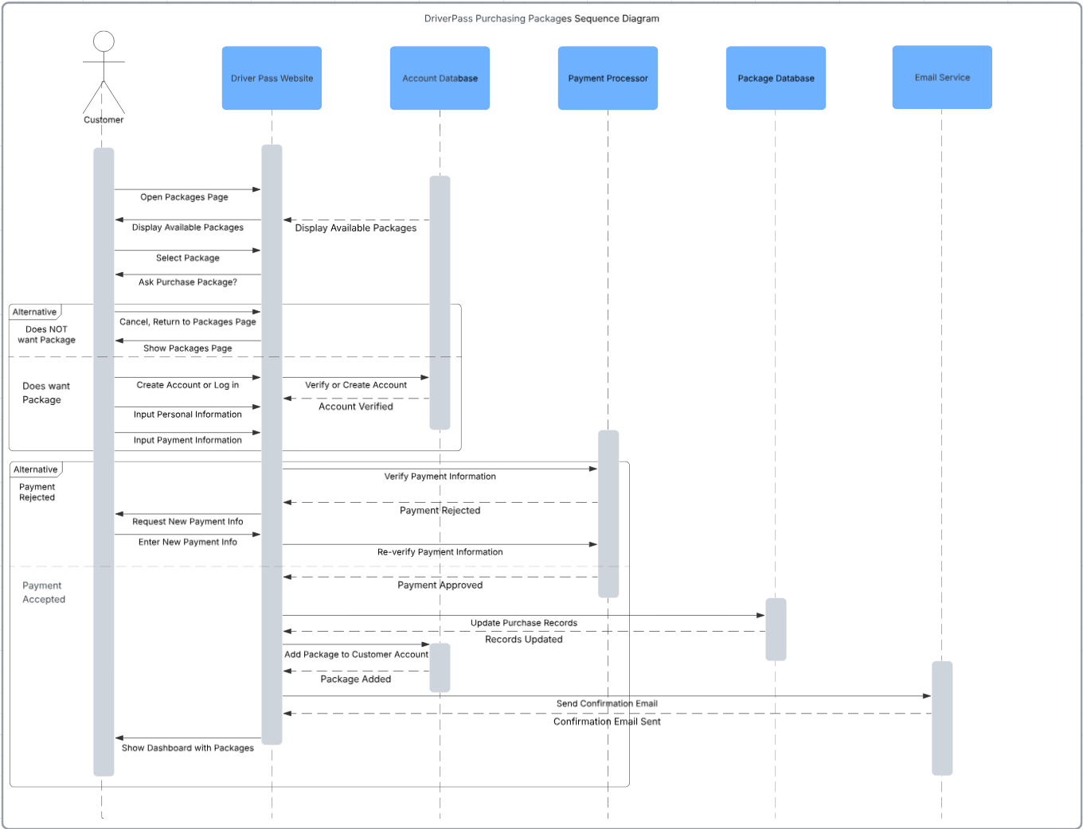

UML Class Diagram
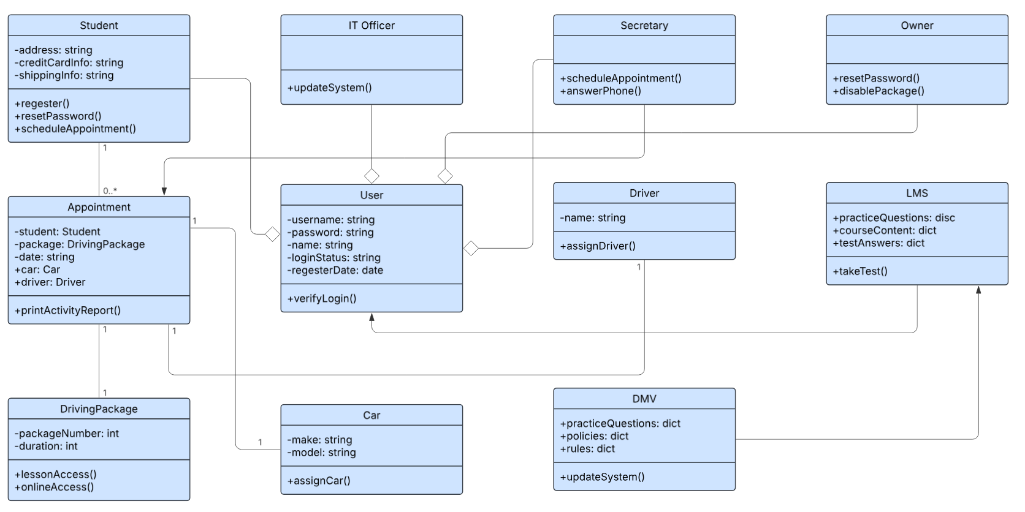

Technical Requirements
The DriverPass system should be launched as a web-based application, which is hosted on a cloud-based server. The cloud-based server will also store user information, appointment scheduling, car and driver, and other necessary information on databases. The system must also be able to access the local DMV’s database for updating new rules and policies and will update automatically. There will also be different control access for users based on their roles, such as owner, it officer, secretary, and customer. Finally, the DriverPass system must be able to run on any modern device that is connected to the internet, and thus also has internet access.

